# 实验任务：练习二维图像的基本操作

### 实验要求：

• 读取、显示

• 生成灰度图

• 生成R,G,B单通道图

• 对图像的Box滤波

• 计算图像的水平、垂直梯度

• （可选）计算图像的整体梯度

### 实验设计：

**读取：**

Mat cv::imread(const String & filename, int flags =

IMREAD_COLOR )

filename: 为图像文件名

flags取默认值即可

该函数将返回一个图像的像素矩阵

**显示：**

void glDrawPixels(GLsizei width, GLsizei height, GLenum format, GLenum type, const GLvoid *pixels)

width, height分别表示图像的宽度和高度

format: GL_RGB对应显示RGB图像， GL_RED,GL_GREEN,GL_BLUE分别对应显示图像的 Red,Green,Blue通道，GL_LUMINANCE可以用于显示灰度图像

type: 本实验设为GL_UNSIGNED_BYTE即可

**生成灰度图：**

cvtColor(IMG_MAT, IMG_GRAY, CV_RGB2GRAY);//转化为灰度图

glDrawPixels(IMG_WIDTH, IMG_HEIGHT, GL_LUMINANCE, GL_UNSIGNED_BYTE, IMG_GRAY.data);

**生成R,G,B单通道图：**

split(IMG_MAT, IMG_RGB);//通道分割

glDrawPixels(IMG_WIDTH, IMG_HEIGHT, GL_RED, GL_UNSIGNED_BYTE, IMG_RGB[0].data);//显示RED通道图

glDrawPixels(IMG_WIDTH, IMG_HEIGHT, GL_BLUE, GL_UNSIGNED_BYTE, IMG_RGB[1].data);//显示BLUE通道图

glDrawPixels(IMG_WIDTH, IMG_HEIGHT, GL_GREEN, GL_UNSIGNED_BYTE, IMG_RGB[2].data);//显示GREEN通道图

**对图像的Box滤波：**

Mat BOX_KERNEL = Mat::ones(Size(KERNEL_SIZE, KERNEL_SIZE), CV_32F) / (float)(KERNEL_SIZE * KERNEL_SIZE);

filter2D(IMG_MAT, IMG_BOX_FILTER, -1, BOX_KERNEL);

glDrawPixels(IMG_WIDTH, IMG_HEIGHT, GL_RGB, GL_UNSIGNED_BYTE, IMG_BOX_FILTER.data);//滤波

**计算图像的水平、垂直梯度：**

Mat VERT_GRAD_KERNEL = (Mat_<float>(3, 3) << 0, 0, 0, -1, 0, 1, 0, 0);

Mat HORZ_GRAD_KERNEL = (Mat_<float>(3, 3) << 0, -1, 0, 0, 0, 0, 1, 0);

filter2D(IMG_GRAY, IMG_HORZ_EDGE, -1, HORZ_GRAD_KERNEL);//水平梯度

filter2D(IMG_GRAY, IMG_VERT_EDGE, -1, VERT_GRAD_KERNEL);//垂直梯度

glDrawPixels(IMG_WIDTH, IMG_HEIGHT, GL_LUMINANCE, GL_UNSIGNED_BYTE, IMG_HORZ_EDGE.data);//水平梯度

glDrawPixels(IMG_WIDTH, IMG_HEIGHT, GL_LUMINANCE, GL_UNSIGNED_BYTE, IMG_VERT_EDGE.data);//垂直梯度

**计算图像的整体梯度：**

Mat ALL_GRAD_KERNEL = (Mat_<float>(3, 3) << 0, -1, 0, -1, 0, 1, 1, 0);

filter2D(IMG_GRAY, IMG_ALL_EDGE, -1, ALL_GRAD_KERNEL);//整体梯度

glDrawPixels(IMG_WIDTH, IMG_HEIGHT, GL_LUMINANCE, GL_UNSIGNED_BYTE, IMG_ALL_EDGE.data);//整体梯度

### 核心代码：

using namespace cv;

float IMG_HEIGHT(600);

float IMG_WIDTH(600);

int KERNEL_SIZE = 13;

Mat IMG_MAT;

Mat IMG_GRAY;

Mat IMG_RGB[3];

Mat IMG_BOX_FILTER;//滤波

Mat IMG_VERT_EDGE;//水平

Mat IMG_HORZ_EDGE;//垂直

Mat IMG_ALL_EDGE;//整体

Mat IMG_ABS_IMG_VERT_EDGE;

Mat IMG_ABS_IMG_HORZ_EDGE;

Mat GRAD;

Mat BOX_KERNEL = Mat::ones(Size(KERNEL_SIZE, KERNEL_SIZE), CV_32F) / (float)(KERNEL_SIZE * KERNEL_SIZE);

Mat VERT_GRAD_KERNEL = (Mat_<float>(3, 3) << 0, 0, 0, -1, 0, 1, 0, 0);

Mat HORZ_GRAD_KERNEL = (Mat_<float>(3, 3) << 0, -1, 0, 0, 0, 0, 1, 0);

Mat ALL_GRAD_KERNEL = (Mat_<float>(3, 3) << 0, -1, 0, -1, 0, 1, 1, 0);

void init(void){

glClearColor(1.0, 1.0, 1.0, 0.0);

glPixelStorei(GL_UNPACK_ALIGNMENT, 1);

}

void reshape(int w, int h){

glViewport(0, 0, w, h);

glMatrixMode(GL_PROJECTION);

glLoadIdentity();

gluOrtho2D(0, IMG_WIDTH,0, IMG_HEIGHT);

}

void loadImage(){

Mat img_bgr = cv::imread("tiger-03.jpg", cv::IMREAD_COLOR);

// 图像沿Y轴方向的镜像翻转

flip(img_bgr, img_bgr, 1);

// 将图像从 BGR 颜色模式转换为 RGB颜色模式

Mat img_rgb;

cvtColor(img_bgr, img_rgb, COLOR_BGR2RGB);

// 获取图像大小（高度对应矩阵的行数，宽度对应列数）

MatSize img_size = img_rgb.size;

IMG_HEIGHT = img_size[0];

IMG_WIDTH = img_size[1];

// 将图像绕Z轴逆时针旋转180度

Mat M = cv::getRotationMatrix2D(cv::Point2f(IMG_WIDTH / 2, IMG_HEIGHT / 2), 180.0, 1.0);

warpAffine(img_rgb, IMG_MAT, M, cv::Size(IMG_WIDTH, IMG_HEIGHT));

cvtColor(IMG_MAT, IMG_GRAY, CV_RGB2GRAY);//转化为灰度图

split(IMG_MAT, IMG_RGB);//通道分割

filter2D(IMG_MAT, IMG_BOX_FILTER, -1, BOX_KERNEL);

//filter2D(IMG_GRAY, IMG_HORZ_EDGE, -1, HORZ_GRAD_KERNEL);//水平梯度

//filter2D(IMG_GRAY, IMG_VERT_EDGE, -1, VERT_GRAD_KERNEL);//垂直梯度

//filter2D(IMG_GRAY, IMG_ALL_EDGE, -1, ALL_GRAD_KERNEL);//整体梯度

}

void display(){

glClear(GL_COLOR_BUFFER_BIT);

glRasterPos2i(0, 0);

//glutPostRedisplay();

//glDrawPixels(IMG_WIDTH, IMG_HEIGHT, GL_RGB, GL_UNSIGNED_BYTE, IMG_MAT.data);//生成RGB图像

//glDrawPixels(IMG_WIDTH, IMG_HEIGHT, GL_LUMINANCE, GL_UNSIGNED_BYTE, IMG_GRAY.data);//灰度图

//glDrawPixels(IMG_WIDTH, IMG_HEIGHT, GL_RED, GL_UNSIGNED_BYTE, IMG_RGB[0].data);//显示RED通道图

//glDrawPixels(IMG_WIDTH, IMG_HEIGHT, GL_BLUE, GL_UNSIGNED_BYTE, IMG_RGB[1].data);//显示BLUE通道图

//glDrawPixels(IMG_WIDTH, IMG_HEIGHT, GL_GREEN, GL_UNSIGNED_BYTE, IMG_RGB[2].data);//显示GREEN通道图

glDrawPixels(IMG_WIDTH, IMG_HEIGHT, GL_RGB, GL_UNSIGNED_BYTE, IMG_BOX_FILTER.data);//滤波

//glDrawPixels(IMG_WIDTH, IMG_HEIGHT, GL_LUMINANCE, GL_UNSIGNED_BYTE, IMG_HORZ_EDGE.data);//水平梯度

//glDrawPixels(IMG_WIDTH, IMG_HEIGHT, GL_LUMINANCE, GL_UNSIGNED_BYTE, IMG_VERT_EDGE.data);//垂直梯度

//glDrawPixels(IMG_WIDTH, IMG_HEIGHT, GL_LUMINANCE, GL_UNSIGNED_BYTE, IMG_ALL_EDGE.data);//整体梯度

glutSwapBuffers();

//glEnd();

glFlush();

}

### 运行结果：

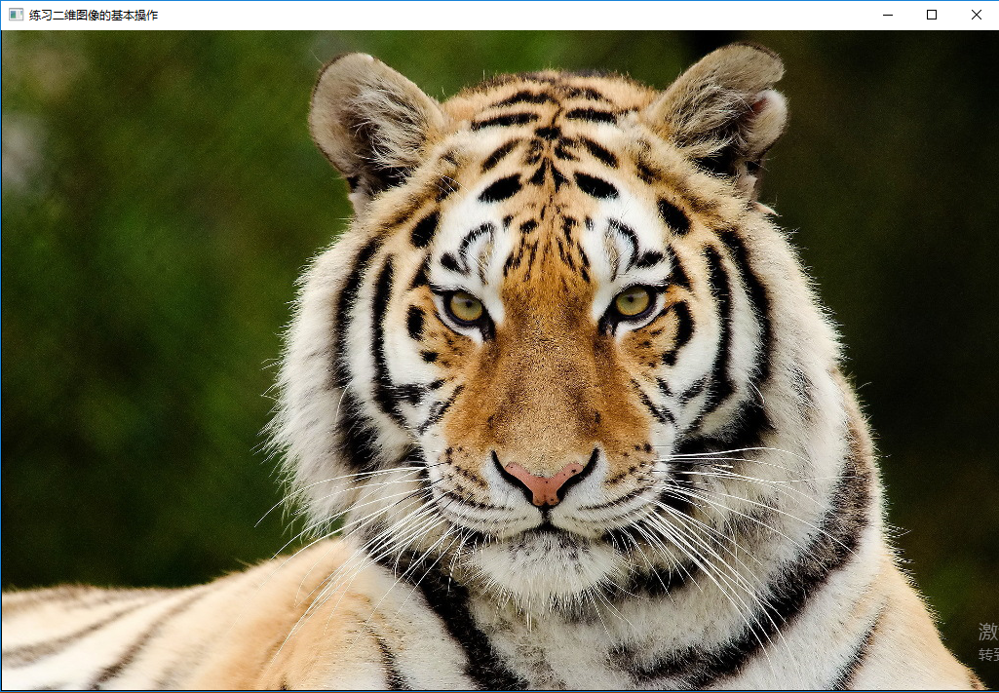

图 1 读取、显示

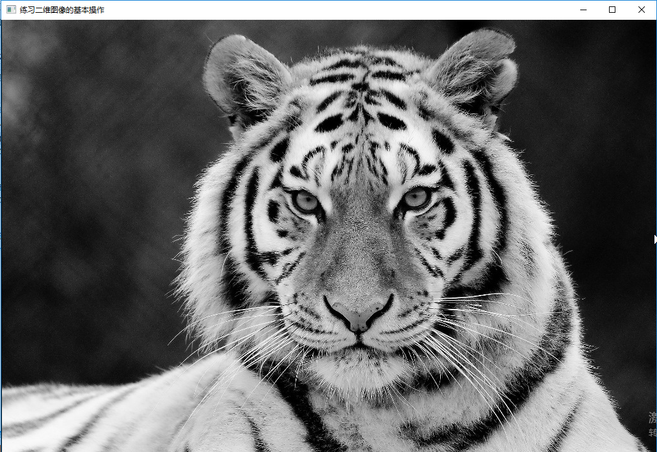

图 2 灰度图

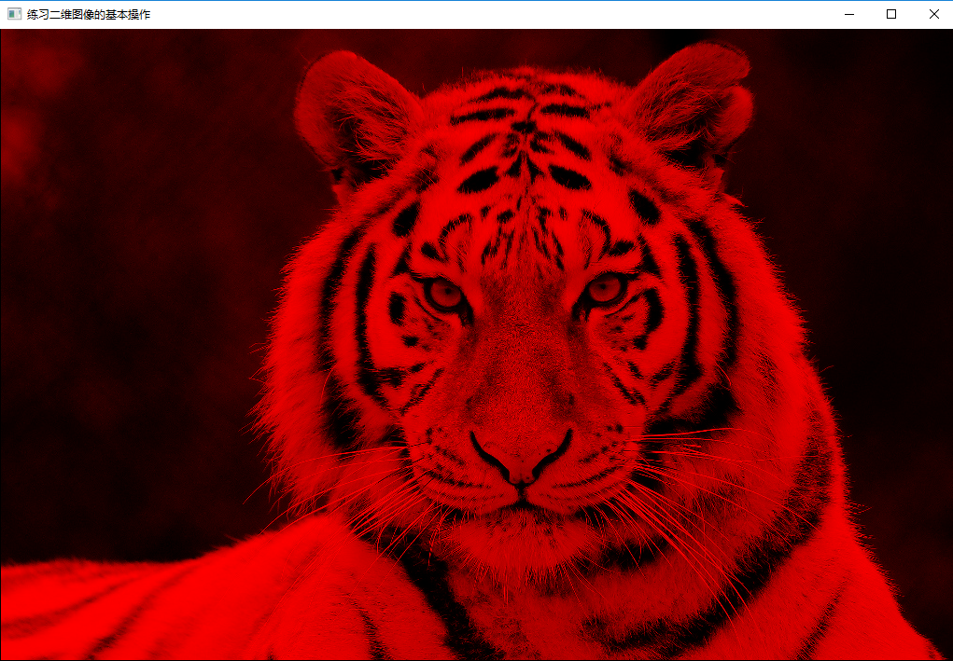

图 3 红色通道

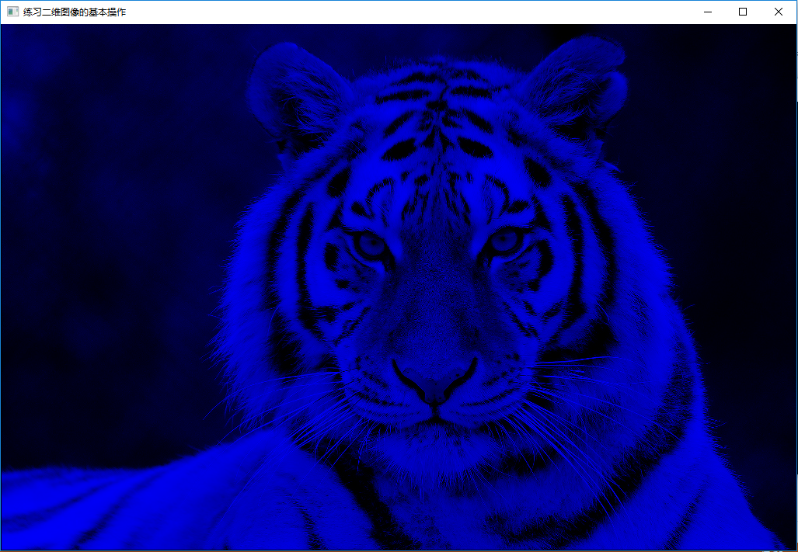

图 4 蓝色通道

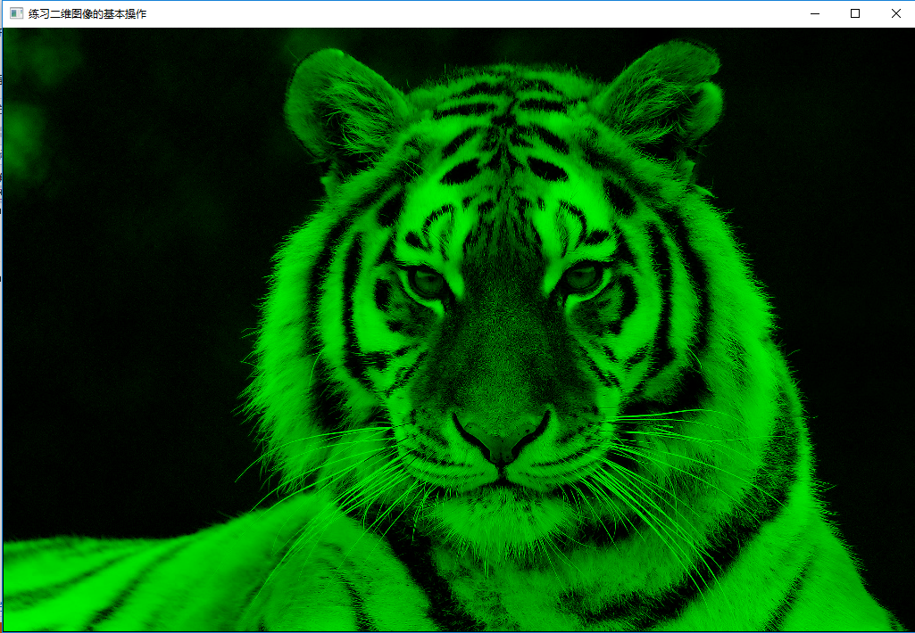

图 5 绿色通道

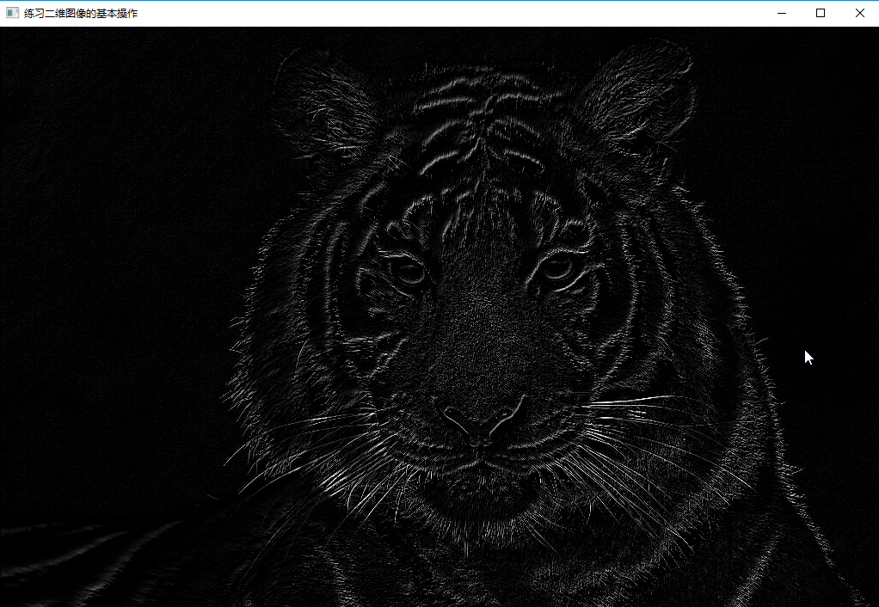

图 6 水平梯度

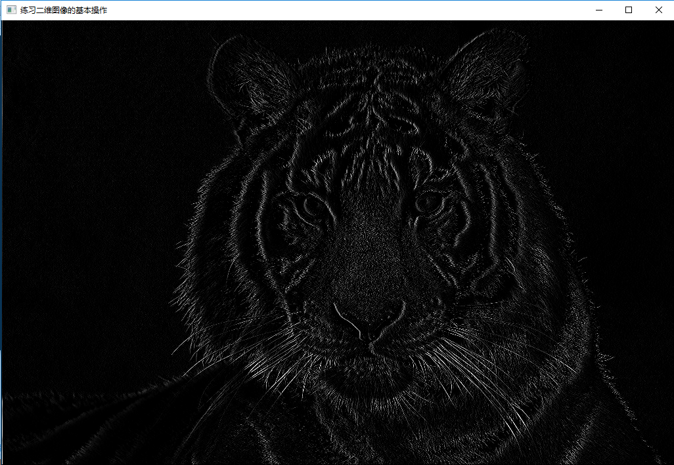

图 7 垂直梯度

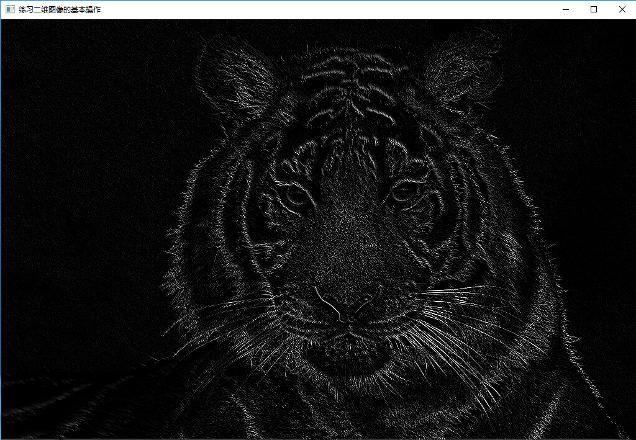

图 8 整体梯度

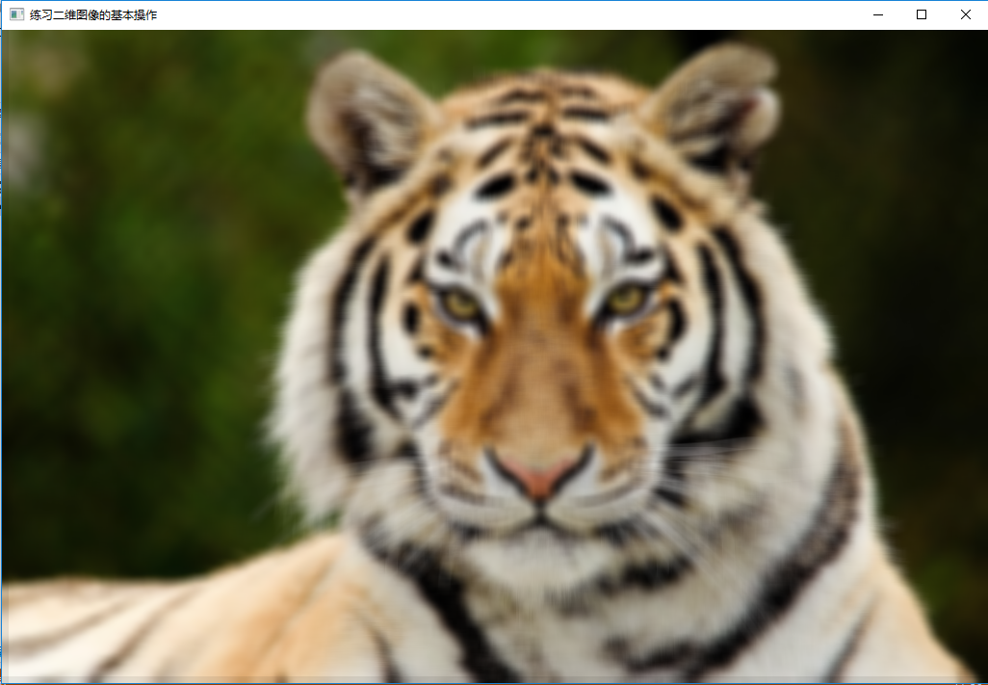

图 9 Box滤波